**DESIGN CODE:**

module lift(in,clk,rst,out,ns);

localparam s0=2'b00,s1=2'b01,s2=2'b10,s3=2'b11;

input clk,rst;

input [1:0]in;

output out;

output reg [1:0]ns;

reg [1:0]ps;

always@(posedge clk or negedge rst)

if(!rst)

begin

ps=s0;

ns=s0;

end

else

begin

ps=ns;

case(ps)

s0:case(in)

2'b00:ns=s0;

default:ns=s1;

endcase

s1:case(in)

2'b00:ns=s0;

2'b01:ns=s1;

default:ns=s2;

endcase

s2:case(in)

2'b11:ns=s3;

2'b10:ns=s2;

default:ns=s1;

endcase

s3:case(in)

2'b11:ns=s3;

default:ns=s2;

endcase

endcase

end

assign out =(ps==in)?1:0;

endmodule

**TESTBENCH**

module lift_test;

localparam s0=2'b00,s1=2'b01,s2=2'b10,s3=2'b11;

reg clk,rst;

reg [1:0]in;

wire out;

wire [1:0]ns;

lift eg(in,clk,rst,out,ns);

initial

repeat(10)

begin

#5clk=0;

#5clk=1;

end

initial

begin

$dumpfile("dump.vcd");

$dumpvars(1);

rst=0;

in=0;

#5rst=1;

#5in=3;

$display("in=%d",in);

#5$display("ns=%b",ns);

end

endmodule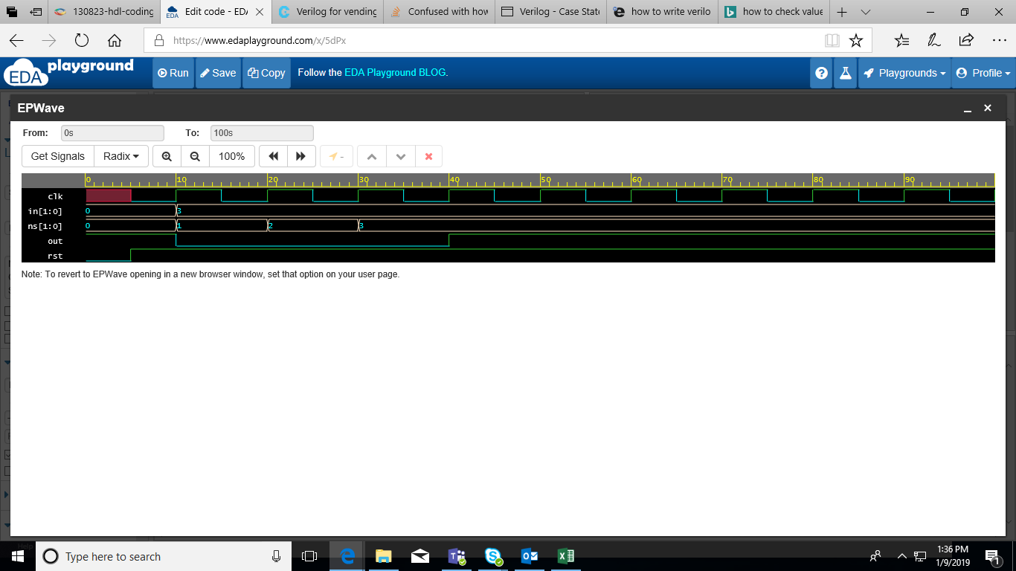

ATM

module atm(clk,pin,choice,amount,envelope,Out)

input [12:0]pin;

input clk,w_d,amount,envelope;

localparam Ins_card=3'b000,Pin_check=3'b001,w_d=3'b010,Account=3'b011;Amount=3'b100,Ins_envelope=3'b101,Wdraw=3'b110;

output out;

always@(posedge clk)

begin

if(!rst)

begin

PS=Ins_card;

NS=Ins_card;

end

else

begin

PS=NS;

case(PS)

Ins_card:NS=(pin==3478)?w_d:Ins_card;

w_d:case(choice)

1'b1: